The second MCI group Project client meeting will be held in Zoom at 2:00pm on Tuesday 16th March 2021

Agenda

**Chair:** Eric Ma

**Secretary:** Jason Ng

**1 Apologies**

None.

**2 Presentation**

[AoE Prototype v0.5 (Figma Link)](https://www.figma.com/file/rzIzKXMMsuvZwdmDKJ2dyJ/Atlas-of-Emotions?node-id=0%3A1)

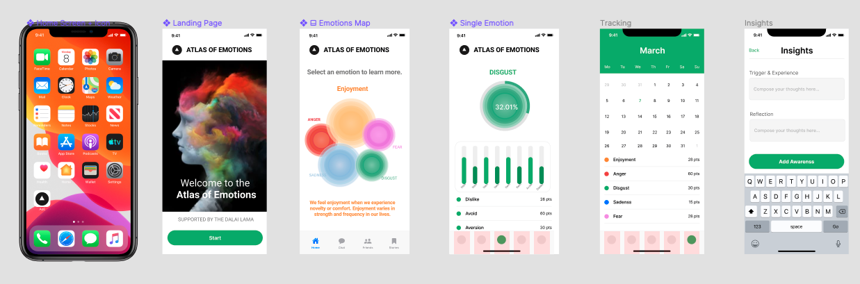

**3 Requirements Elicitation**

3.1 Name of the app

3.2 Feedback on the presented prototype and prioritising major features:

* Landing Page - Welcome messages
* Five Emotions Maps
* Single Emotion Analysis
* (Insights / Suggestions and solutions)
* Daily and Monthly tracking

3.3 List of emotional states shall be reported

3.4 Presentation of trigger and response of emotions

**4 Other Issues**

4.1 Sample data for app testing

4.2 Why developing the app and what values the app could offer

**Note:** Next meeting will be held on 23rd March 2021